Practical No. 4
Aim : WAP to show the use of all methods of string class
Name : Danish Altaf Solkar | Class : CO - B
Enrolment no. : 24111590805 | Batch : 2

Code :-
class StringDemo
{
public static void main(String [] args)
{
String str = new String("Hello");
String str1 = "Danish";
String str2 = "Solkar";
System.out.println("Length of string : "+str1.length());
System.out.println("Concatenating str1 and str2 : "+str1.concat(str2));
System.out.println("Replace a with h in programming : "+str1.replace('a','h'));
System.out.println("Converting string into lowercase : "+str2.toLowerCase());
System.out.println("Converting string into uppercase : "+str2.toUpperCase());
System.out.println("Strings equality : "+str1.equals(str2));
System.out.println("Character at 5th index of string : "+str2.charAt(3));
}
}
OUTPUT :-
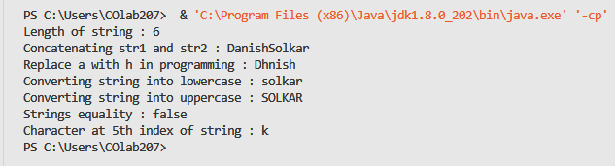

Process related  (35) | Product related  (15) | Total Marks  (50) | Signature

Practical No. 4
Aim : WAP to implement all methods of StringBuffer
Name : Danish Altaf Solkar | Class : CO - B
Enrolment no. : 24111590805 | Batch : 2

Code :-
class StringBufferDemo {
public static void main(String[] args) {
StringBuffer str = new StringBuffer("Programming");
StringBuffer str2 = new StringBuffer("Good");
System.out.println("Reverse : " + str.reverse());
System.out.println("Deleting char from index 3 to 6 : " + str.delete(3, 6));
System.out.println("Appending str and str2 : " + str2.append(str));
System.out.println("Inserting easy at index 4 in str2 : " + str2.insert(4, "easy"));
}
}

OUTPUT :-
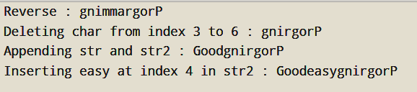

Process related  (35) | Product related  (15) | Total Marks  (50) | Signature

